The ClaimCenter Data Model Solution

Exercise 1: Configuration

The solution is shown in the screenshots below. (The display keys have not been included.)

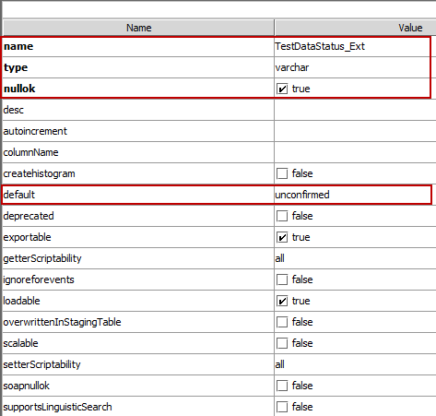



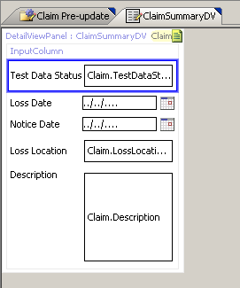

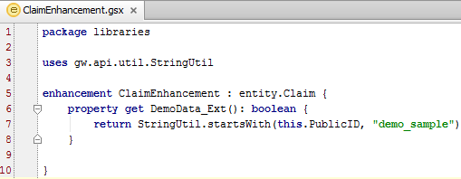

package libraries

uses gw.api.util.StringUtil

enhancement ClaimEnhancement : entity.Claim {

property get DemoData_Ext(): boolean {

return StringUtil.startsWith(this.PublicID, "demo_sample")

}

}

